**Проект “Моделирование изменения балансов студентов”**

with first_payments as (

select

user_id

,date_trunc('day', min(transaction_datetime)) as first_payment_date

from skyeng_db.payments

where status_name = 'success'

group by user_id

),

all_dates as (

select distinct date_trunc ('day', class_start_datetime) as dt

from skyeng_db.classes

where date_trunc ('day', class_start_datetime) between '2016-01-01 00:00'and '2016-12-31'

),

all_dates_by_user as (

select user_id, dt

from first_payments

join all_dates on dt >= first_payment_date

),

payments_by_dates as (

select

user_id

, date_trunc('day', transaction_datetime) as payment_date

, sum (classes) as transaction_balance_change

from skyeng_db.payments

where status_name = 'success'

group by user_id, payment_date

),

payments_by_dates_cumsum as (

select

ad.user_id

, dt

, coalesce (transaction_balance_change,0) as transaction_balance_change

, sum (coalesce (transaction_balance_change,0)) over (partition by ad.user_id order by dt) as transaction_balance_change_cs

from all_dates_by_user ad

left join payments_by_dates pd

on ad.user_id = pd.user_id

and payment_date = dt

),

classes_by_dates as (

select

user_id

, date_trunc('day', class_status_datetime) as class_date

, -count (*) as classes

from skyeng_db.classes

where class_status in ('success', 'failed_by_student')

and class_type != 'trial'

group by user_id, class_date

),

classes_by_dates_cumsum as (

select

adu.user_id

, dt

, coalesce (classes, 0) as classes

, sum (coalesce (classes,0)) over (partition by adu.user_id order by dt) as classes_cs

from all_dates_by_user adu

left join classes_by_dates cd

on adu.user_id = cd.user_id

and dt = class_date

),

balances as (

select

pdcum.user_id

, pdcum.dt

, transaction_balance_change

, transaction_balance_change_cs

, classes

, classes_cs

, (cdcum.classes_cs + pdcum.transaction_balance_change_cs) as balance

from payments_by_dates_cumsum pdcum

full join classes_by_dates_cumsum cdcum

on pdcum.user_id = cdcum.user_id

and pdcum.dt = cdcum.dt

order by pdcum.user_id

, pdcum.dt

)

-- select *

-- from balances

-- order by balance

-- limit 1000

select dt,

sum(transaction_balance_change) as total_transaction_balance_change,

sum(transaction_balance_change_cs) as total_transaction_balance_change_cs,

sum(classes) as total_classes,

sum(classes_cs) as total_classes_cs,

sum(balance) as total_balance

from balances

group by dt

order by dt

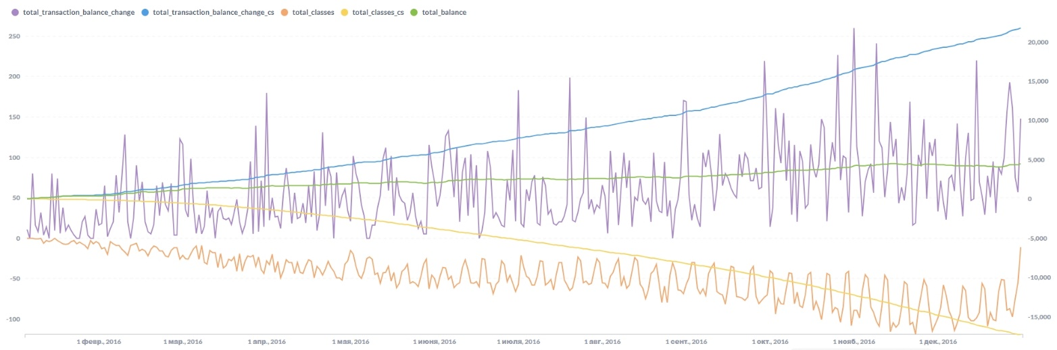

**ВЫВОДЫ**

Вопросы к дата-инженерам и владельцам таблицы payments:

Выявлено 142 примера отрицательного баланса из первых 1000 строк, т.е. некоторые ученики получали уроков больше, чем оплатили.

Нужно обратить на это внимание, даже если позже они докупали уроки, выходя в плюс. Возможны ошибки в системе начисления/списания уроков.

По итогу на 31.12.2016 на балансе остаётся большое количество уроков (= 4 533). Сложно сказать, связано ли это с организационными проблемами в самой школе или с планированием самих учеников, возможно стоит провести опрос. Также можно наблюдать более активную покупку уроков с сентября и до конца года.